NAME: |  |  |  | TEAM: |  |  |  |  |  |  | DATE ORDERED:
CONTACT PHONE NUMBER:

EMAIL ADDRESS:

ITEMS |  |  |  |  | SIZE/S |  |  | QUANTITY |  |  |  | PRICE | AMOUNT TO PAY
PLAYING DRESS (SIZING GUIDE BELOW) |  |  |  |  |  |  |  |  |  |  |  | $70
MATCHING SHORTS (XXS TO XXL) |  |  |  |  |  |  |  |  |  |  |  | $35
COMPLETE UNIFORM (dress + shorts) |  |  |  |  |  |  |  |  |  |  |  | $100
TRAINING T SHIRT (BLACK OR WHITE) |  |  |  |  |  |  |  |  |  |  |  | $20
CLUB TRAINING SINGLET(10 to 14, XXS TO XXL) |  |  |  |  |  |  |  |  |  |  |  | $20
CLUB POLO SHIRT 6 to 24 (adults sizes) |  |  |  |  |  |  |  |  |  |  |  | $25
KIDS TRAINING SHORTS (8 10 12 14) |  |  |  |  |  |  |  |  |  |  |  | $25
TRAINING TIGHTS (XXS TO XXL) |  |  |  |  |  |  |  |  |  |  |  | $40
*PLAIN BLACK ZIPPED HOODIE |  |  |  |  |  |  |  |  |  |  |  | $35
*CUSTOM BLACK/BLUE TRIM HOODIE |  |  |  |  |  |  |  |  |  |  |  | $50
*LONG-LINE ALL-WEATHER JACKET |  |  |  |  |  |  |  |  |  |  |  | $65
CLUB SPORTS GEAR BAG |  |  |  |  |  |  |  |  |  |  |  | $45
CLUB BACK PACK |  |  |  |  |  |  |  |  |  |  |  | $35
CLUB BLACK CAP |  |  |  |  |  |  |  |  |  |  |  | $15
CLUB BLACK VISOR |  |  |  |  |  |  |  |  |  |  |  | $10
METHOD OF PAYMENT (x) |  |  |  | CASH |  |  | CHEQUE |  |  |  | CREDIT CARD
DIRECT DEBIT |  |  | DETAILS – BSB: 012-477 ACCOUNT NO: 2486-76135
TOTAL AMOUNT DUE TO BE PAID |  |  |  |  |  |  |  |  |  | $
☑ Tick or highlight type of card |  |  | - Master card |  |  |  |  |  |  | - Visa
DETAILS FOR PAYMENT BY CREDIT CARD | Name on card: |  |  |  |  |  |  |  |  |  |  |  | Exp date:
DETAILS FOR PAYMENT BY CREDIT CARD | Card No: |  |  |  |  |  |  |  |  |  |  |  | CVC:

*SIZING GUIDES
Plain black hoodies: 6 to 14 (kids), 8 to 18 (adults) |  |  |  |  | Custom hoodies YXS to YXL (kids), XS to XL (adults) |  |  |  |  |  | Long-line Jackets: XXS to 3XL
Playing dress: use the following guide
Kids 6 | Kids 8 | Kids 10 | Kids 12 | Kids 14 |  | Ladies 8 | Ladies 10 | Ladies 12 | Ladies 14 | Ladies 16 |  | Ladies 18 | Ladies 20 | Ladies 22
6 | 8 | 10 | 12 | 14 |  | 16 | 18 | 20 | 22 | 24 |  | 26 | 28 | 30

PLAYING DRESS | 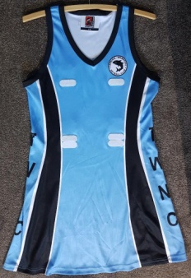 | LONG-LINE ALL-WEATHER JACKET | 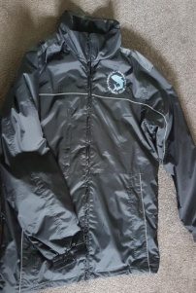  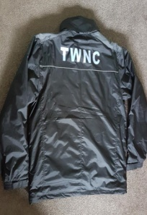
MATCHING SHORTS | 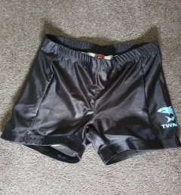 | PLAIN BLACK ZIPPED HOODIE | 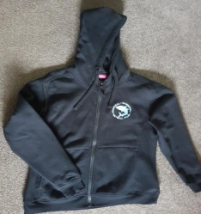
TRAINING T SHIRT  (BLACK OR WHITE) | 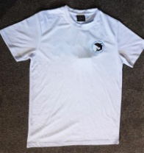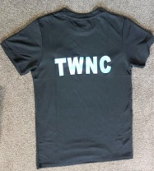 | CUSTOM BLACK/BLUE TRIM HOODIE | 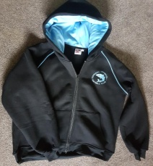
CLUB TRAINING  SINGLET | 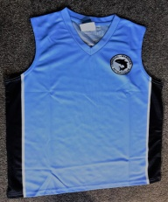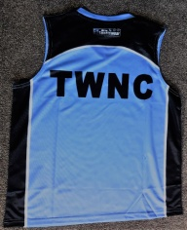 | CLUB SPORTS GEAR BAG | 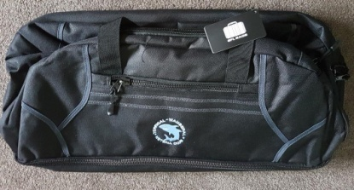
CLUB POLO SHIRT | 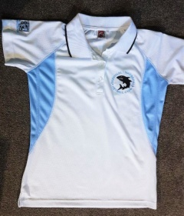 | CLUB BACK PACK | 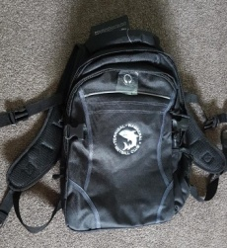
KIDS TRAINING  SHORTS | 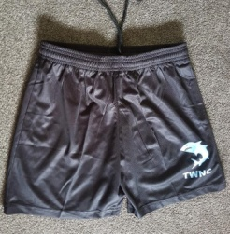 | CLUB BLACK CAP | 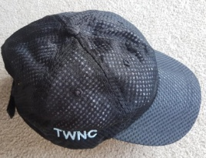
TRAINING TIGHTS | 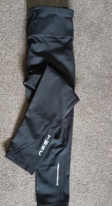 | CLUB BLACK VISOR | 